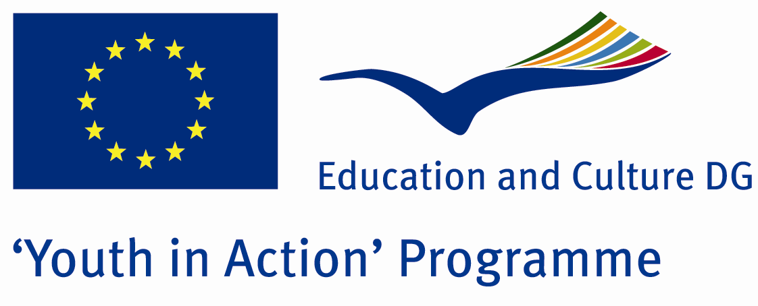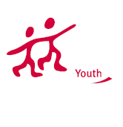

Human Heart


ACTION 1.1 – Youth Exchange

18th - 25th July, 2012

Uşak, TURKEY

ACTION 1.1 - Youth Exchange

Please contact directly to;
eirenegroup@gmail.com
Project Summary;

Natural disasters, and major destruction occurred without the influence of people killing people and property damage by natural events. These are drought, famine, severe cold weather, earthquakes, floods, landslides, avalanches, storms, hurricanes, volcanoes, forest fires and etc. Natural disasters, most countries have not known in advance caught unprepared, so the higher losses of life and property. These disasters occur all over the world, and collaborate, and improves the support of the people. Many countries help to get rid of this disaster and lots of people make a bridge, heart to heart.

The aim of our project is prepared for natural disasters, deliberate and cold-blooded people who will help in such situations is to create. So that each participant adds a wood this bridge.

If you want to join this project, please contact us..

Project Title; Human Heart

Date and Venue ; 18th - 25th July 2012
Uşak, Turkey .

Target Group ; Municipalities, City Councils and Non-Governmental organizations,
youth groups,culture and art groups,e.t.c

Participants ; 5 people from each country (over 18 -25 ). Totally 8 countries.

Conditions ; Accommodation, board and programme costs will be financed through European Commission Youth in Action Programme ….Travel costs will be reimbursed in 70% (APEX Tarrifs). Organizations from all 27 EU member countries plus Liechtenstein , Norway and Iceland are eligible to take part.

Working language: English

Organizer; GRUP EİRENE

How to apply: If you are interested, please send your Part III forms to
by e-mail please. Scan Part3 format is enough for application. (Fulfilled Part III which you can find in the attachment, of course signed and stamped) ..

If you have any questions you may contact with:
eirenegroup@gmail.com
Deadline for application; until 10th October 2011.

